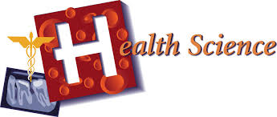

VISION
Health Science Education advances the understanding of the role of health care in society and lays the groundwork for a well-prepared health care workforce.

MISSION
The mission of Health Science Education (Biomedical Science Program) is to prepare students for successful careers by building a solid foundation of the required knowledge and skills that lead to careers in therapeutic services, diagnostic services, health informatics, support services or biotechnology.

SCOPE
The Health Science program is designed to prepare students for entry-level employment in health care and/or for further education in medical careers.

New Montana Career Pathway (Programs of Study) Requirements (2017-2018)

A statewide career pathway is a program of inter-connected academic & elective classes revolving around a career or subject theme. It is integrated with experiential learning and close connections between high school and college, training and apprenticeship. The program is designed to support the development of career and life readiness (21st Century Skills) for the learner, so the student can successfully enter and advance in a career path.
- A minimum of 1 credit of CTE non-duplicative, sequential courses must be offered. A rigorous core of coursework in math and science is recommended for all students interested in pursuing careers in health care. Course offerings vary across the state, however Exploration of Health Careers and Human Body Systems (A & P) should be offered as foundational coursework. PLTW courses Principles of Biomedical Science and Human Body Systems also meet Core requirements.
- Career Exploration Activities and/or HOSA- Future Health Professionals
- There are several courses and/or activities that may be offered to fulfill work-based learning and/or industry recognized credentials.

SPECIFIC PROGRAM REQUIRMENTS
For a program to be approved and receive state vocational education and Perkins funding, teachers must be endorsed in Health Science and offer a minimum of two semesters of coursework that address the Core Curriculum Model:
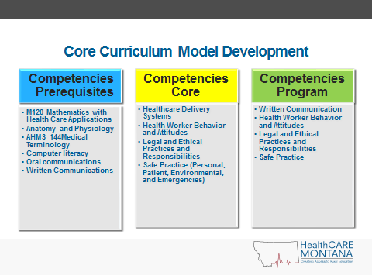
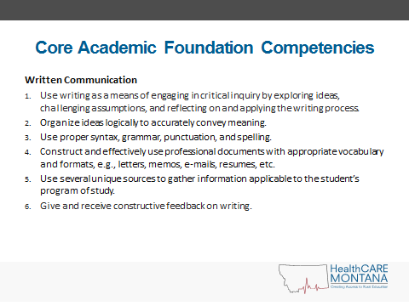

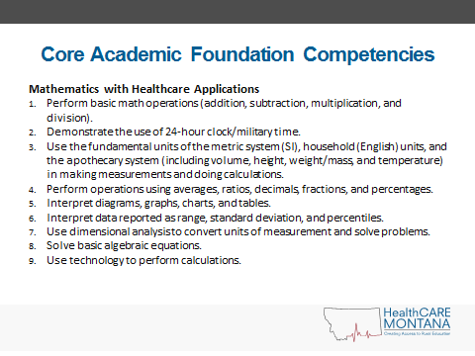
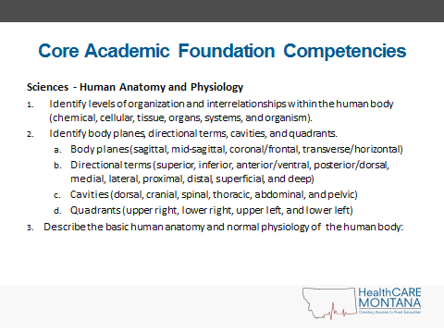
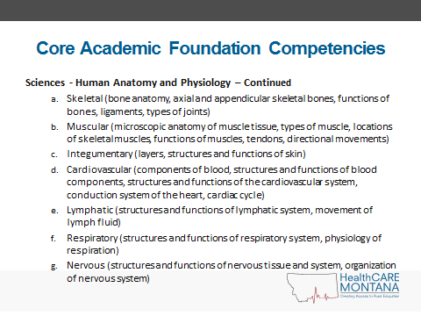
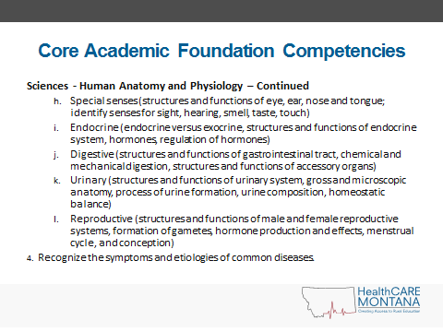
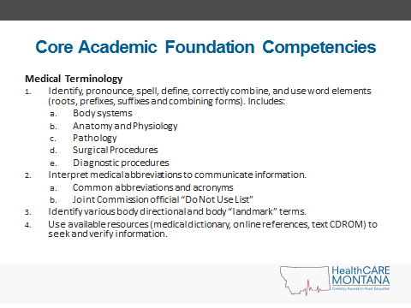
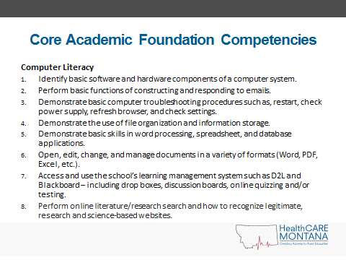
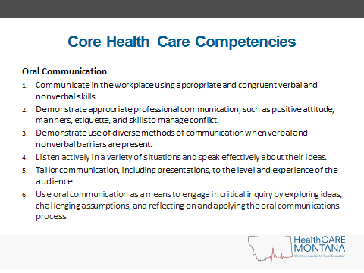
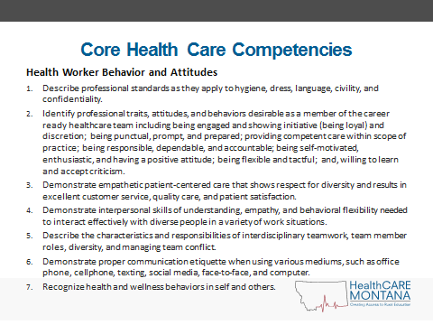
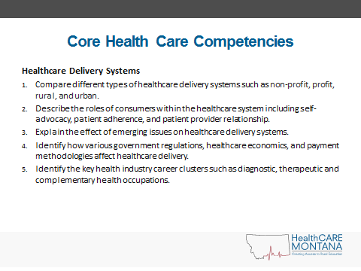
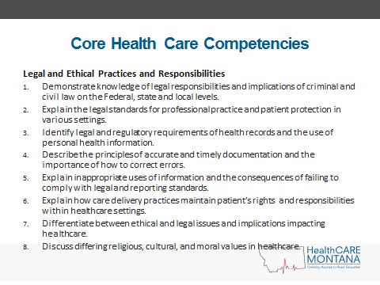
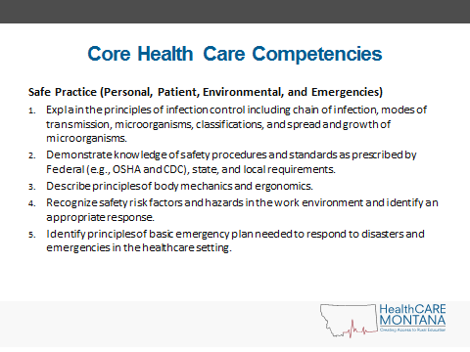

Health Science Course Offered in MT (They may have different names, but the course content follows these descriptions.
14001 Exploration of Health Care Careers (.5 credit)
Exploration of Health Care Careers- this course exposes students to the variety of opportunities available within the health care industry (e.g., such as nursing, therapy, dental care, administrative services, and lab technology). This course provides experiences in several of these occupational clusters, along with information and knowledge related to the health care industry as a whole.

14002 Health Care Occupations—Comprehensive (1.0 credit)
Health Care Occupations—this comprehensive course provides students with an orientation to the health care industry and helps refine their health care-related knowledge and skills. Topics covered usually include (but are not limited to) an overview of health care delivery; patient care, including assessment of vital signs, body mechanics, and diet; anatomy and physiology; identification and use of medical equipment and supplies; medical terminology; hygiene and disease prevention; first aid and CPR procedures; laboratory procedures; and ethical and legal responsibilities.

03053 Anatomy and Physiology/Human Body Systems (.5 credit or 1.0 credit if yr-long )
This course is also called “Human Body Systems” in many Health Science programs. Usually taken after a comprehensive initial study of biology, Anatomy and Physiology courses present the human body and biological systems in more detail. In order to understand the structure of the human body and its functions, students learn anatomical terminology, study cells and tissues, explore functional systems (skeletal, muscular, circulatory, respiratory, digestive, reproductive, nervous, and so on), and may dissect mammals.

14051 Nursing (Nursing Assistant) (.5 credit)
Nurse Assistant courses in Montana must be taught by a licensed nurse (LPN or RN) that is registered with the Dept. of Public Health and Human Services.
This course places special emphasis on the particular knowledge and skills required of nursing assistants and aides while covering general health care topics (i.e., patient care, anatomy and physiology, medical terminology, hygiene and disease prevention, first aid and CPR, and laboratory procedures). Topics covered typically include normal growth and development; bathing, feeding, dressing, and transporting patients; basic pharmacology; doctor, nurse, and patient relationships and roles; medical and professional ethics; death and dying; and care of various kinds of patients (e.g. chronically ill, children, new mothers, and so on).

14055 Emergency Medical Technology (.5 credit)
Emergency Medical Technology courses must be taught by certified EMT instructors.
This course places special emphasis on the knowledge and skills needed in medical emergencies. Topics typically include clearing airway obstructions, controlling bleeding, bandaging, methods for lifting and transporting injured persons, simple spinal immobilization, infection control, stabilizing fractures, and responding to cardiac arrest. The courses may also cover the legal and ethical responsibilities involved in dealing with medical emergencies.

14062 Care of Athletes (Sports Medicine) (.5Credit)
Care of Athletes is generally taught by an Athletic Trainer.
This course provides students with the knowledge and skills to understand and perform therapeutic tasks that would be designated by an athletic or fitness trainer. Topics covered may include taping and bandaging, proper use of protective padding, treatment modalities, anatomy and physiology, and medical terminology. Students may learn to measure cardio-respiratory endurance, muscular strength and endurance, flexibility, body composition, and blood pressure. More advanced topics may include injury assessment, the phases of healing, and the use of exercise and equipment to help in the reconditioning of injured athletes.

14098 Therapeutic Services—Workplace Experience
Therapeutic Services-Workplace Experience courses provide students with work experience in
fields related to therapeutic services. Goals are typically set cooperatively by the student, teacher, and employer (although students are not necessarily paid). These courses may include classroom activities as well, involving further study of the field or discussion regarding experiences that students encounter in the workplace.

14099 Therapeutic Services—Other (“Case Studies” Course being piloted in Great Falls)
14152 Pharmacy Assisting
Pharmacy Technician courses are available online at many two-year colleges in MT, and available online through PassAssured (seat license fee per student). www.passassured.com Certification testing at student’s expense.
The Pharmacy Assisting course emphasizes the knowledge and skills necessary to assist a pharmacist or pharmacy technician. Course topics and experiences enable students to understand medical terminology, keep and maintain records, label medications, perform computer patient billing, perform stock inventory, and order supplies. These courses also emphasize pharmaceutical classification, drug interactions, and interpersonal/communication skills.

14153 Medical Office Procedures
Medical Office Procedures courses expose students to clerical knowledge, abilities, and
procedures as they apply to the medical field. These courses typically include (but are not limited to) topics such as medical transcription, medical insurance, financial accounting, scheduling, and patient record-keeping. Medical terminology and routine medical procedures are covered to provide a context for clerical duties.

14154 Medical Terminology
Offered On-line from COTs,; check CM Russell HS and Bozeman HS for inclusion of this as a dual credit course.
In Medical Terminology courses, students learn how to identify medical terms by analyzing their components. These courses emphasize defining medical prefixes, root words, suffixes, and abbreviations. The primary focus is on developing both oral and written skills in the language used to communicate within health care professions.

14251 Health Science (PLTW Biomedical Science years 1 and 2) (2.0 credits)
For full description of Biomedical Science programming, go to www.pltw.org
Health Science courses integrate chemistry, microbiology, chemical reactions, disease processes, growth and development, and genetics with anatomy and physiology of the body systems. Typically, these courses reinforce science, mathematics, communications, health, and social studies principles and relate them to health care.

14252 Biotechnology (PLTW Biomedical Science years 3 and 4) (2.0 credits)
Biotechnology courses involve the study of the bioprocesses of organisms, cells, and/or their
components and enable students to use this knowledge to produce or refine products, procedures, and techniques. Course topics typically include laboratory measurement, monitoring, and calculation; growth and reproduction; chemistry and biology of living systems; quantitative problem-solving; data acquisition and display; and ethics. Advanced topics may include elements of biochemistry, genetics, and protein purification techniques.

14998 Health Care Sciences—Workplace Experience
Health Care Sciences—Workplace Experience courses provide students with work experience in
the health care industry. Goals are typically set cooperatively by the student, teacher, and employer (although students are not necessarily paid). These courses may include classroom activities as well, involving further study of the field or discussion regarding experiences that students encounter in the workplace.

We are looking into Behavioral Health as an additional option for students in the health science career pathway.

INSTRUCTOR QUALIFICATIONS:
Health Professionals with certification in the following areas and at least 10,000 hours may apply for Class 4B or Class 4C endorsement to teach health science (Athletic trainer; exercise physiology; kinesiology/exercise science; medical or clinical assistant; medical laboratory technician; pharmacy technician; pharmacist; radiologic technology; physician assistant; and registered nurse. Contact the Health Science Specialist for other health-related certifications.

Secondary teachers with a teaching certificate in science or health enhancement may also qualify for a health science endorsement. The teacher must have collegiate level anatomy and physiology or human biology; complete an online 80 hour health science course (offered each summer); and complete a job shadow in a medical facility.
PROGRAM GUIDELINES

Work-based Learning
Students are provided with workplace experience in fields related to medical or veterinary services. Goals are typically set cooperatively by the student, teacher and employer (although students are not necessarily paid). These courses may include classroom activities as well, involving further study of the field or discussion regarding experiences the students encounter in the workplace.

Regional Area Health Education Centers (AHEC) offers REACH experiences across the state. Research and Explore Awesome Careers in Healthcare is a day-long hands-on tour of your local or regional medical facility.

Med Start Camp is also offered by regional AHEC offices and is a week-long summer camp that immerses students in health related activities and job shadowing.

Eastern AHEC- Mary Helgeson, director 406-247-3297
North Eastern AHEC- Beth Brunk, outreach coordinator 406-234-1424
South Central AHEC- Natascha Robinson, Director 406-457-8048
North Central AHEC- Shani Rich, Director 406-457-8018
Western AHEC- Martha Robertson, program coordinator 406-243-4746

Facilities and Equipment
The type and amount of equipment needed in medical careers courses varies with the program objectives, size of class and facility. Contact the Health Science Education Specialist if you would like additional information pertaining to supplies for specific courses.

Career and Technical Student Organization (CTSO)
“HOSA- Future Health Professionals”, is the designated student organization for students pursuing careers in health care. Classes involved in HOSA activities fulfill the Perkins requirement of providing leadership activities to CTE students in this area. If a class is not affiliated with HOSA, the teacher is required to explain their specific leadership activities before gaining program approval.

